Report for The Douglas Bomford Trust
Trip to Italy – An insightful journey
It was a great privilege to attend this course titled "Big Data and Digital Tools Applied to Livestock Production" at the University of Padova, Italy, from September 25 – 29, 2023. This course is a multi-disciplinary training with substantial engineering content directly applicable to Animal - and other Agricultural production systems. There were participants from UK, Europe and South America, which gave room for networking with other professionals around the world.
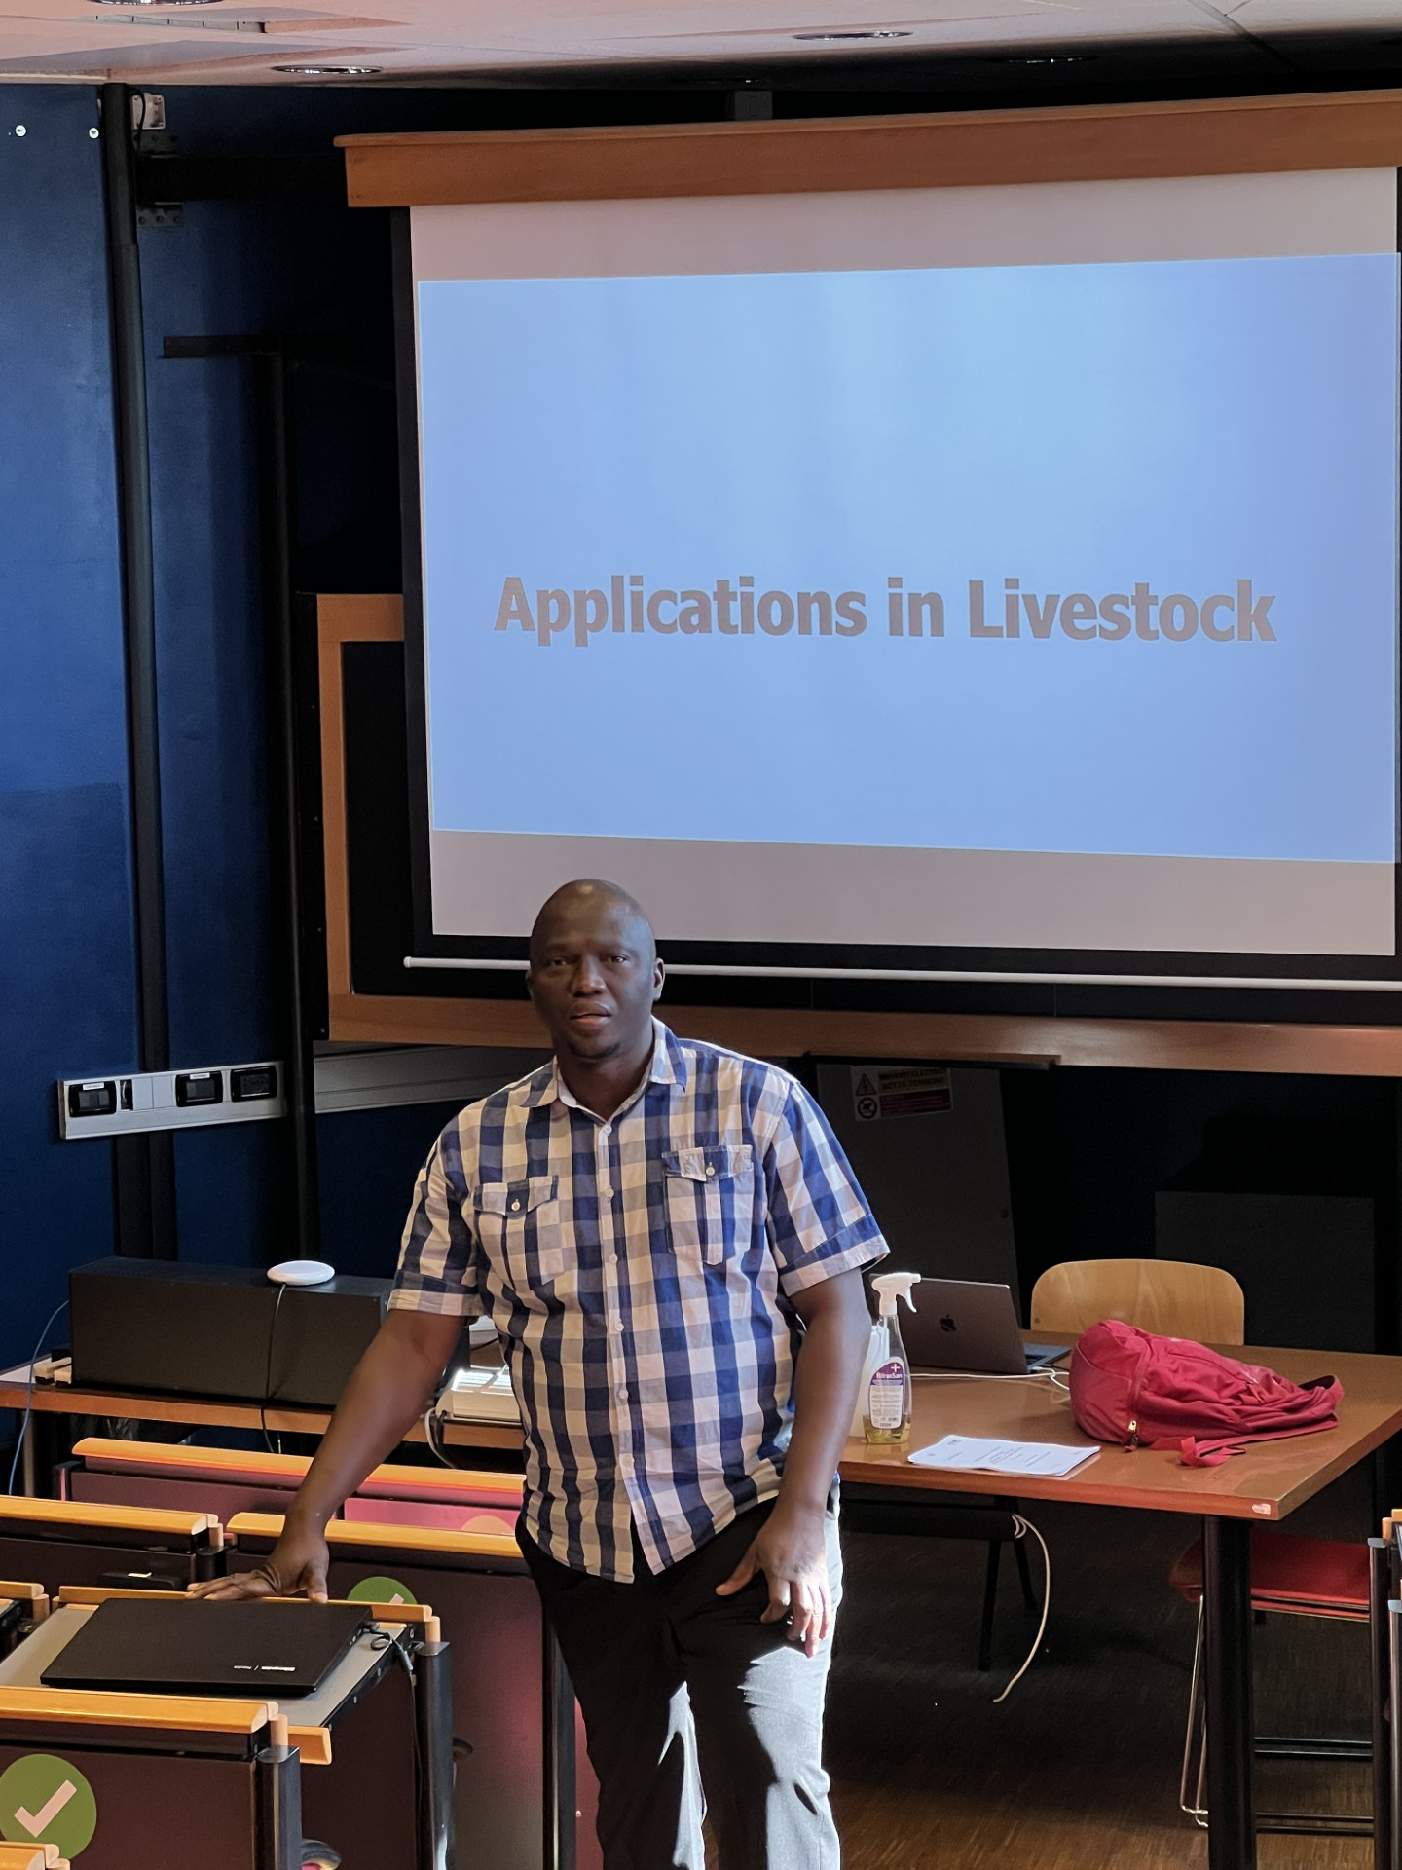
I attended this course to extend my knowledge, hone my skills in this field of Agricultural technology, and improve milk yield and welfare of dairy cows. My goal is to apply this knowledge to my PhD research. I am currently undergoing my PhD programme as a Postgraduate Researcher at the University of the West of England, Bristol, and Hartpury University, Gloucester. My research focuses on using Automatic Monitoring Systems to assess water intake and drinking behaviour of dairy cows under grazing conditions.
This 5-day programme was loaded with different topics cutting across different fields and areas with lectures and practical sessions. These fields include engineering, data analysis, computer vision and machine learning, physical sciences, genetics, genomics, animal production, nutrition, and Animal welfare. The topics were tailored and tutored so that, irrespective of each participant's different fields of study, everyone could acquire knowledge in his/her field. I participated in all aspects of the course to gather as much knowledge as possible across the different topics/areas. However, my emphasis was more on the topics that are more relevant and directly related to my PhD study.Some of these topics are:
· Digital Agriculture: Precision Livestock Management: data integration and data processing; data analytics tools and goals; data streaming and processing, digital agriculture, sensor technology and data collection etc
· Wearable Sensing Technology: Accelerometer, magnetometers, light sensors etc
· Principles of Data Analysis: image processing and analysis, regression and classification, multidimensional data and model regularisation.
I plan to incorporate the knowledge and skills I garnered in this course in my Ph.D. research through the appropriate use and interpretation of the required technology and tools, data collection and processing. My participation in this course has boosted my knowledge, understanding, practice, competence, and capability in the application of engineering and physical science to my study.
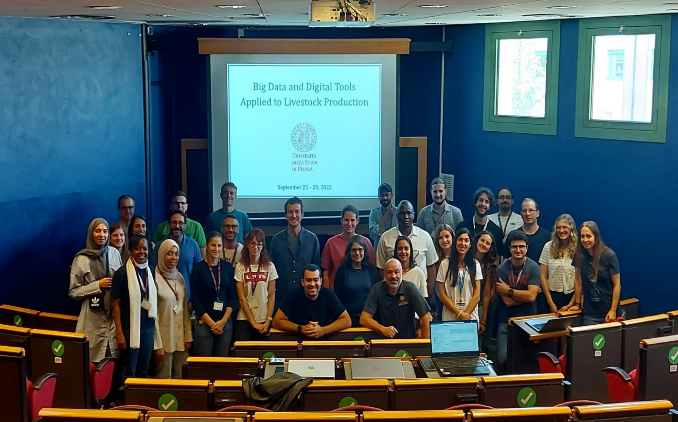
Finally, I express my profound gratitude to The Douglas Bomford Trust for sponsoring my trip to this programme. Also, thank Mr. Alan Plom for his doggedness to ensure everything went well during the application process and my supervisors (Prof. Matt Bell, Dr(s). Alexandros Stratakos, Dayane Teixeira, and Daniel Hidalgo) for their support.
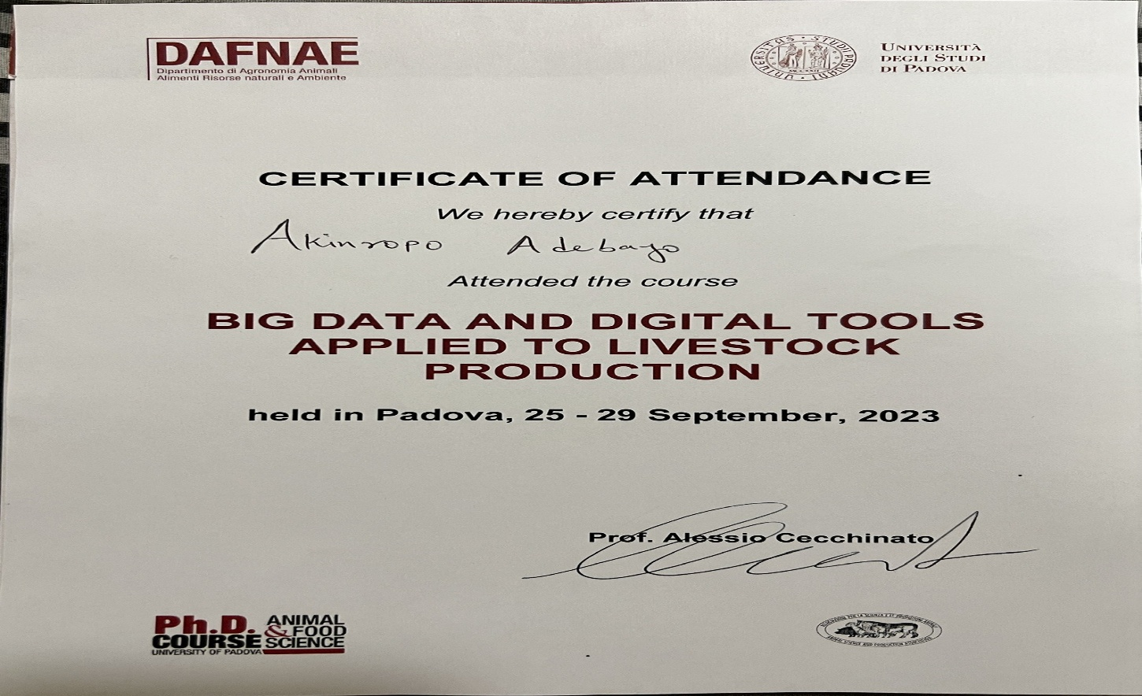
Thank you all. I plan to contact the organisation for more opportunities like this.
Best regards,
Akinropo Adebayo

